**WEEK-09**

**Question 1**

**Write a Java program to create a method that takes an integer as a parameter**

**and throws an exception if the number is odd.**

**Sample input and Output:**

**82 is even.**

**Error: 37 is odd.**

**Fill the preloaded answer to get the expected output.**

**For example:**

| **Result** |
| --- |
| **82 is even.**  **Error: 37 is odd.** |

**Program:**

**public class OddEvenCheck {**

**// Custom exception for odd numbers**

**static class OddNumberException extends Exception {**

**public OddNumberException(String message) {**

**super(message);**

**}**

**}**

**public static void checkEven(int number) throws OddNumberException {**

**if (number % 2 != 0) {**

**throw new OddNumberException(number + " is odd.");**

**} else {**

**System.out.println(number + " is even.");**

**}**

**}**

**public static void main(String[] args) {**

**// Sample numbers to check**

**int[] numbers = {82, 37};**

**for (int number : numbers) {**

**try {**

**checkEven(number);**

**} catch (OddNumberException e) {**

**System.out.println("Error: " + e.getMessage());**

**}**

**}**

**}**

**}**

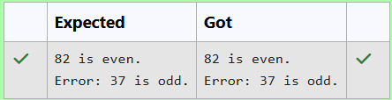

**Question 2**

**In the following program, an array of integer data is to be initialized.  
During the initialization, if a user enters a value other than an integer, it will throw an InputMismatchException exception.  
On the occurrence of such an exception, your program should print “You entered bad data.”  
If there is no such exception it will print the total sum of the array.**

**/* Define try-catch block to save user input in the array "name"  
   If there is an exception then catch the exception otherwise print the total sum of the array. */**

**Sample Input:**

**3  
5 2 1**

**Sample Output:**

**8**

**Sample Input:**

**2**

**1  g**

**Sample Output:**

**You entered bad data.**

**For example:**

| **Input** | **Result** |
| --- | --- |
| **3**  **5 2 1** | **8** |
| **2**  **1 g** | **You entered bad data.** |

**Program:**

**import java.util.Scanner;**

**import java.util.InputMismatchException;**

**public class ArrayInputDemo {**

**public static void main(String[] args) {**

**Scanner scanner = new Scanner(System.in);**

**int size = scanner.nextInt();**

**int[] numbers = new int[size];**

**try {**

**for (int i = 0; i < size; i++) {**

**numbers[i] = scanner.nextInt(); // This line can throw InputMismatchException**

**}**

**// Calculate the total sum**

**int sum = 0;**

**for (int number : numbers) {**

**sum += number;**

**}**

**// Print the total sum**

**System.out.println(sum);**

**} catch (InputMismatchException e) {**

**System.out.println("You entered bad data.");**

**} finally {**

**scanner.close(); // Close the scanner resource**

**}**

**}**

**}**

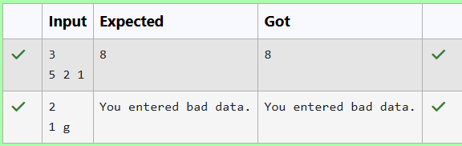

**Question 3**

**Write a Java program to handle ArithmeticException and ArrayIndexOutOfBoundsException.**

**Create an array, read the input from the user, and store it in the array.**

**Divide the 0th index element by the 1st index element and store it.**

**if the 1st element is zero, it will throw an exception.**

**if you try to access an element beyond the array limit throws an exception.**

**Input:**

**5**

**10  0 20 30 40**

**Output:**

**java.lang.ArithmeticException: / by zero  
I am always executed**

**Input:**

**3  
10   20   30**

**Output  
java.lang.ArrayIndexOutOfBoundsException: Index 3 out of bounds for length 3  
I am always executed**

**For example:**

| **Test** | **Input** | **Result** |
| --- | --- | --- |
| **1** | **6**  **1 0 4 1 2 8** | **java.lang.ArithmeticException: / by zero**  **I am always executed** |

**Program:**

**import java.util.Scanner;**

**public class ExceptionHandlingDemo {**

**public static void main(String[] args) {**

**Scanner scanner = new Scanner(System.in);**

**// Read the size of the array**

**int size = scanner.nextInt();**

**// Declare the array**

**int[] array = new int[size];**

**// Read the elements into the array**

**for (int i = 0; i < size; i++) {**

**array[i] = scanner.nextInt();**

**}**

**// Attempt to perform division and access an out-of-bounds index**

**try {**

**// This will throw an ArithmeticException if array[1] is zero**

**int result = array[0] / array[1];**

**} catch (ArithmeticException e) {**

**System.out.println(e);**

**}**

**try {**

**// This will throw an ArrayIndexOutOfBoundsException if size <= 3**

**int outOfBoundsValue = array[3];**

**} catch (ArrayIndexOutOfBoundsException e) {**

**System.out.println(e);**

**}**

**// This will always execute**

**System.out.println("I am always executed");**

**scanner.close();**

**}**

**}**

